MS-601
PRINCIPLES & PRACTICES OF MANAGEMENT
Complete Exam Study Guide
Scope locked to your corrected syllabus
1) Introduction to Management 2) Principles & Practices of Management 3) Evolution of Management 4) Making Decisions 5) Managing External Environment. Diversity has been removed. The separate Global Environment chapter, Social Responsibility & Ethics, and other non-syllabus chapters are not included as study units.

Exam pattern captured from your course material
Short questions: 1–2 marks. Long questions: 8–10 marks. Short case studies: maximum 2. Making Decisions: no numerical questions. Contingency approach: long-question emphasis. Design Thinking + Big Data: 1 mark. Organizational Culture: short/2-mark emphasis. Overview decision-making diagram: not for the exam. Leader-focused questions: not for the exam.

This guide combines the relevant uploaded lectures, the corrected syllabus, the previous study coverage, diagrams/exhibits, model answers, short-question banks, long-answer structures and case-study practice.

Contents
Section | What you will study
Unit 0 | How to Study This Guide + Exam Strategy
Unit 1 | Introduction to Management
Unit 2 | Principles & Practices of Management
Unit 3 | Evolution of Management Thought
Unit 4 | Making Decisions
Unit 5 | Managing the External Environment & Organizational Culture
Final | High-Yield Revision Sheets
Final | Question Bank + Case Studies

How to Use This Guide
- First pass: understand every definition and distinction in the concept sections.
- Second pass: memorize the items explicitly marked MUST MEMORIZE, especially Fayol’s 14 principles, Mintzberg’s roles, Katz’s skills, the 8-step decision process, decision biases, the uncertainty matrix and the 7 culture dimensions.
- Third pass: answer the short questions without looking at the answers, then practice the long-answer structures.
- Final pass: do the case studies using the templates in the final section.
Answer-writing formula for 8–10 marks
Definition/intro → diagram or classification → explain each component → example → advantages/limitations or criticism → short conclusion. Use headings and underlined keywords. Do not write a continuous wall of text.

UNIT 1 — INTRODUCTION TO MANAGEMENT
Course-source note: Main sources: 601 INTRODUCTION TO MANAGEMENT; 601 PRINCIPLES AND PRACTICES OF MANAGEMENT. The introductory deck defines organization, management, the management process, nature, levels, Mintzberg roles, Katz skills and managerial functions.
UNIT 1 EXAM MAP
Definitions → P-O-L-C → nature of management → purpose → levels → manager vs operative → Mintzberg roles → Katz skills → managerial functions → value of studying management.

1. Organization, Goal, Management and Manager
Term | Exam-ready meaning | Example
Organization | Two or more people working together in a structured way to achieve a specific goal or set of goals. | A company, hospital, university, NGO
Goal | The purpose an organization strives to achieve. An organization may have multiple goals. | Profit, service quality, growth
Management | The process of planning, organizing, leading and controlling organizational work and resources to achieve stated goals. | Running a department or company
Manager | A person responsible for directing efforts toward organizational goals. | Team manager, department head, CEO

2. Management Process — P-O-L-C
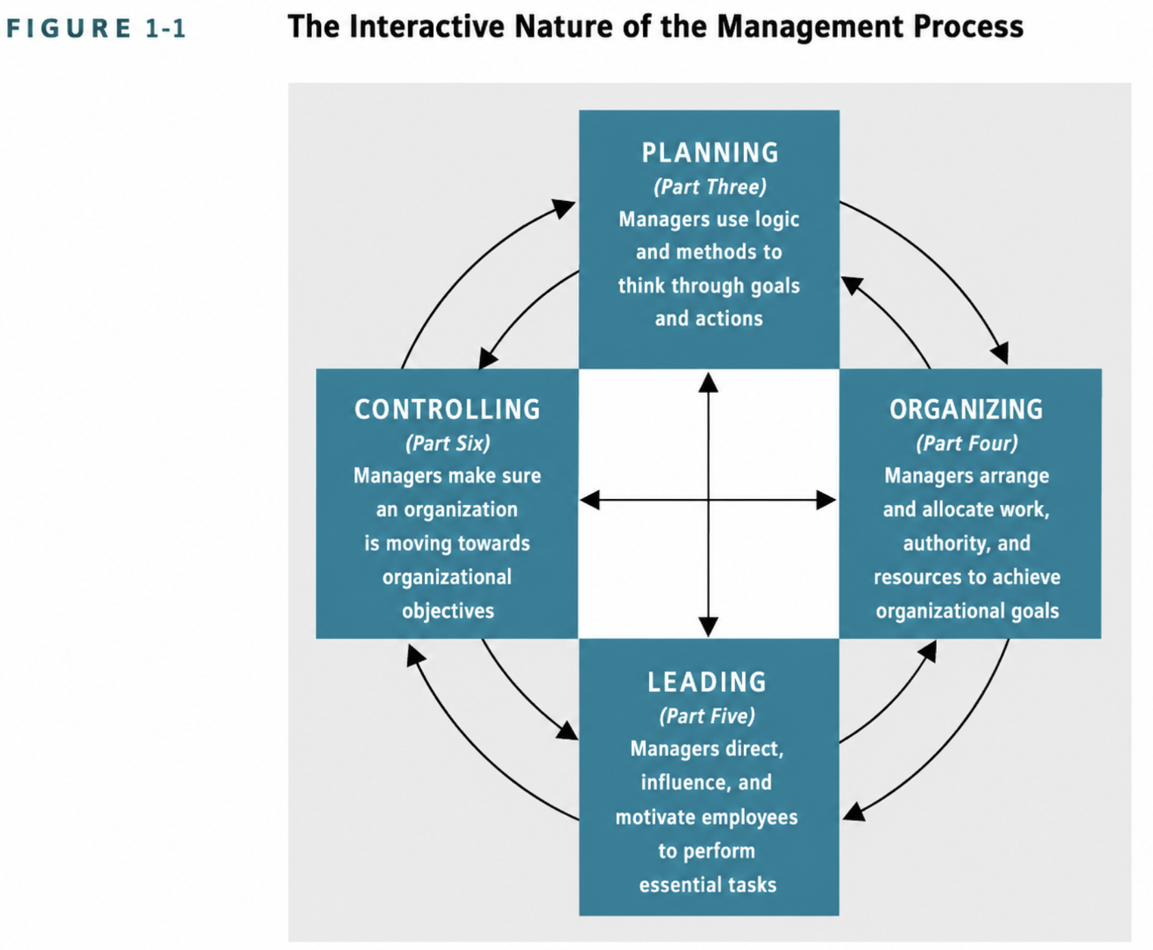
Course figure: interactive nature of the management process (Introduction to Management, slide 4).
Function | Meaning | Typical manager questions
Planning | Establish goals and choose a suitable course of action. | What are we trying to achieve? How? By when?
Organizing | Arrange people, work, authority and resources into a structured system. | Who does what? Who reports to whom? What resources are needed?
Leading | Direct and influence people so they perform task-related activities. | How do I communicate, motivate and guide people?
Controlling | Ensure actual activities conform to planned activities. | What was the standard? What happened? What correction is needed?

Memory hook
Planning decides the destination. Organizing arranges the vehicle and people. Leading gets everyone moving. Controlling checks whether the organization is still on route.

3. Nature / Characteristics of Management
Characteristic | How to explain it in the exam
Goal-oriented | Management is directed toward achieving objectives.
Continuous process | Management continues through planning, organizing, leading and controlling.
Universal | Management is needed in business, education, government, social, religious and other organizations wherever group effort is required.
Group activity | Management coordinates the work of multiple people.
Multidisciplinary | It draws on economics, psychology, sociology, statistics, law and other fields.
Science + art | Science supplies systematic knowledge; art involves judgment, creativity, experience and application.
Profession | Management uses specialized knowledge and formal training.
Dynamic | Managers must adapt to technology, customers, competition and other environmental changes.
Authority system | Formal hierarchy and legitimate authority allow managers to direct resources.
Decision-making | Managers continuously choose among alternatives.
Leadership-related | Effective management also requires the ability to guide and influence people.
Separation of ownership and control | Managers may run an organization without being its owners.
Intangible force | Management is experienced through how the organization functions, reaches targets and maintains order.

4. Purpose of Management
- Reduce ambiguity in the way work is done through SOPs and clear roles/responsibilities.
- Keep costs under control through resource optimization and budgetary control.
- Take calculated risks using data, analysis and cost-benefit evaluation.
- Manage prospective risk using forecasting, crisis planning and contingency planning.
- Exercise judgment by balancing conflicting interests and evidence.

5. Levels of Management

The source slide uses a background image on the levels slide; the exam-relevant content is the three management levels below.
Level | Main responsibility | Examples
Top management | Overall direction; establishes policies and guides interaction with the environment. | CEO, President, Managing Director
Middle management | Manages managers and sometimes operating employees; translates higher-level plans into departmental action. | Department manager, regional manager
First-line management | Directly manages operating employees; lowest managerial level. | Supervisor, shift manager, team leader

6. Manager vs Operative Employee
Manager | Operative employee
Directs the efforts of others toward goals. | Directly performs a task and normally does not supervise others.
Allocates resources and coordinates work. | Uses assigned resources to perform the job.
Makes managerial decisions. | Makes task-level choices within the job.

7. Mintzberg’s Managerial Roles
MUST MEMORIZE: 3 categories → 10 roles
Interpersonal (3): Figurehead, Leader, Liaison. Informational (2): Monitor, Disseminator. Decisional (4): Entrepreneur, Disturbance Handler, Resource Allocator, Negotiator.

Category | Role | What the manager does
Interpersonal | Figurehead | Performs ceremonial and symbolic duties.
Interpersonal | Leader | Hires, trains, motivates and disciplines employees.
Interpersonal | Liaison | Connects the organization/unit with other units and external parties.
Informational | Monitor | Collects and interprets information from multiple sources.
Informational | Disseminator | Passes important information to subordinates.
Decisional | Entrepreneur | Looks for ways to improve the unit or organization.
Decisional | Disturbance handler | Responds to crises, conflicts, shortages, strikes and grievances.
Decisional | Resource allocator | Allocates people, money, equipment and other resources.
Decisional | Negotiator | Mediates conflicts and negotiates with internal/external parties.

8. Katz’s Three Managerial Skills
Skill | Meaning | Example | Importance by level
Technical | Ability to use procedures, techniques and specialized knowledge. | Coding, financial modeling, operating equipment. | Most important at first-line level.
Human | Ability to work with, understand and motivate people. | Communication, empathy, listening. | Important at all levels.
Conceptual | Ability to coordinate and integrate the organization’s interests and activities. | CEO deciding whether to launch a global product. | Most important at top level.

Memory hook
Top → conceptual thinking. Middle → combine conceptual + human. First-line → technical + human. Human skill matters at every level.

9. Functions of a Manager — Detailed
Function | What it includes
Planning | Determining enterprise objectives and selecting future courses of action.
Organizing | Arranging people, materials, technology and finance; dividing work; allocating authority/responsibility; coordinating tasks.
Staffing | Recruiting, selecting, training, developing, motivating and compensating people for positions.
Directing | Guiding and supervising subordinates. Includes leadership, motivation, communication and supervision.
Controlling | Setting standards, measuring actual performance, comparing actual performance with standards and taking corrective action.

10. Directing: low-priority but know the basics
Your corrected syllabus says there are no direct questions about leaders. Therefore, do not spend revision time on detailed leadership theories. However, the PPM lecture lists directing, leadership, motivation, effective communication and supervision, so know their one-line meanings.
- Directing: guiding and supervising subordinate activities.
- Motivation: creating conditions and incentives that encourage employees to perform.
- Communication: effective transmission and understanding of information.
- Supervision: ensuring employees perform work as directed.

11. Why Study Management?
- Management knowledge helps explain how organizations use scarce resources to achieve goals.
- It helps you understand how managers plan, organize, lead and control.
- It improves problem solving and decision making.
- Humanities and social sciences matter because managers work with people and institutions: psychology helps with motivation and behavior; sociology with groups and culture; economics with resource allocation; political science with power and institutions; statistics with evidence and analysis.

12. Rewards and Challenges of a Management Career
Rewards | Challenges
Opportunity to influence organizational outcomes. | Responsibility for other people’s performance.
Potential for career growth and broader responsibility. | Time pressure and conflicting demands.
Ability to work on complex problems. | Uncertainty and incomplete information.
Developing transferable people and decision skills. | Need to balance stakeholders, performance and ethics.

UNIT 1 — Question Bank
[SHORT] Define management.
Answer / points: A process of planning, organizing, leading and controlling organizational work and resources to achieve stated goals.
[SHORT] Define organization.
Answer / points: Two or more people working together in a structured way to achieve one or more goals.
[SHORT] What are the four functions of management?
Answer / points: Planning, organizing, leading and controlling.
[SHORT] Who is a manager?
Answer / points: A person responsible for directing efforts toward organizational goals.
[SHORT] Name the three levels of management.
Answer / points: Top, middle and first-line management.
[SHORT] What is technical skill?
Answer / points: Ability to use specialized procedures, techniques and knowledge.
[SHORT] What is human skill?
Answer / points: Ability to work with, understand and motivate people.
[SHORT] What is conceptual skill?
Answer / points: Ability to coordinate and integrate the organization’s interests and activities.
[SHORT] What is a figurehead role?
Answer / points: A ceremonial/symbolic managerial role.
[SHORT] What is liaison?
Answer / points: A connecting role between the organization/unit and others.
[SHORT] What is the monitor role?
Answer / points: Collecting and interpreting information.
[SHORT] What is resource allocation?
Answer / points: Assigning human, physical and monetary resources among activities.
[SHORT] Why is management called multidisciplinary?
Answer / points: Because it uses knowledge from multiple fields such as economics, psychology, sociology and statistics.
[LONG] Explain the nature of management.
Answer / points: Use: goal-oriented, continuous, universal, group activity, multidisciplinary, science + art, profession, dynamic, authority system, decision making, separation of ownership/control, intangible force.
[LONG] Explain Mintzberg’s managerial roles with examples.
Answer / points: Interpersonal: figurehead, leader, liaison. Informational: monitor, disseminator. Decisional: entrepreneur, disturbance handler, resource allocator, negotiator.
[LONG] Explain Katz’s three managerial skills and relate them to management levels.
Answer / points: Technical is strongest at first-line level; human is important at all levels; conceptual is strongest at top level. Add one example for each.
[LONG] Differentiate top, middle and first-line managers.
Answer / points: Compare scope, responsibilities, reporting relationships and examples.
[CASE] Case: A supervisor is technically excellent but cannot communicate or motivate the team. Which managerial skill is missing? What should be done?
Answer / points: Human skill is weak. The manager needs communication, listening, conflict-handling and motivation capability.

UNIT 2 — PRINCIPLES & PRACTICES OF MANAGEMENT
Course-source note: Main source: 601 PRINCIPLES AND PRACTICES OF MANAGEMENT. The deck lists Planning, Organizing, Directing, Controlling, SWOT, strategic/tactical plans, decision making, group decisions, MBO and case analysis. Detailed explanations below are expanded for study completeness where the source slide only lists the topic.
UNIT 2 EXAM MAP
Planning → benefits → strategic vs tactical → strategic management process → SWOT → MBO → organizing → structure → directing basics → controlling → case analysis.

1. Planning
Planning is the process of determining organizational objectives and selecting future courses of action necessary for their accomplishment.

Benefits of planning
- Provides direction and focus.
- Reduces uncertainty by forcing managers to think about the future.
- Improves coordination and reduces duplication/overlap.
- Provides a basis for control because actual results can be compared with planned standards.
- Improves resource allocation.

2. Strategic vs Tactical Plans
Dimension | Strategic plan | Tactical plan
Scope | Organization-wide | Department/unit
Purpose | Sets broad long-term direction | Converts strategy into concrete departmental actions
Typical level | Top management | Middle management
Detail | Broad | More specific
Example | Enter the Southeast Asian market | Run a 12-month Indonesia launch campaign

3. Strategic Management Process
1. Define current mission, goals and objectives.
2. Analyze the external environment.
3. Analyze internal resources and capabilities.
4. Formulate strategies.
5. Implement strategies.
6. Evaluate results and make corrections.
Exam diagram
External analysis + Internal analysis → Strategy formulation → Implementation → Evaluation/feedback.

4. SWOT Analysis
Element | Internal / External | Meaning | Example
Strengths | Internal | Existing advantages or capabilities. | Strong brand, skilled workforce
Weaknesses | Internal | Internal limitations. | High costs, weak distribution
Opportunities | External | Favorable changes or possibilities. | Growing market, new technology
Threats | External | External conditions that can harm performance. | New competitor, regulation, recession

MUST MEMORIZE
S + W = INTERNAL. O + T = EXTERNAL.

5. Management by Objectives (MBO)
MBO is a management approach in which managers and employees establish objectives and later evaluate performance against those objectives. It emphasizes clarity of expected results and participation.
- Objectives should be specific and measurable.
- Employees should understand and participate in setting objectives.
- Progress should be reviewed.
- Performance should be evaluated against agreed objectives.
Example: Instead of “increase sales,” an MBO objective could be “increase quarterly sales by 12% by the end of Q4.”

6. Organizing
Organizing arranges an organization’s resources — people, materials, technology and finance — so objectives can be achieved. It includes decisions about division of work, authority, responsibility and coordination.

Elements of organization structure
Element | Meaning
Work specialization | Dividing work into smaller specialized tasks.
Departmentalization | Grouping jobs into departments by function, product, geography, customer or process.
Chain of command | Clear line of authority showing who reports to whom.
Span of control | Number of employees directly supervised by a manager.
Centralization | Decision authority concentrated at higher levels.
Decentralization | Decision authority pushed downward to lower levels.
Formalization | Degree to which jobs and behavior are standardized through rules/procedures.

7. Types of Organization Structure
Structure | Basic idea | Advantages | Limitations
Functional | Group by specialized function: marketing, finance, HR, operations. | Specialization, efficiency | Silos, slower cross-functional coordination
Divisional | Group by product, geography or customer. | Responsiveness, accountability | Duplication of resources
Matrix | Dual authority, often functional + project/product manager. | Flexibility, cross-functional collaboration | Conflict and role ambiguity
Team-based | Work organized around teams. | Coordination, collaboration | Can blur individual accountability if poorly designed

8. Directing — Basic Study Note
- Directing = guiding and supervising subordinate activity.
- Leadership = influencing people toward goals.
- Motivation = encouraging effort through meaningful work, recognition, incentives, healthy working conditions and other mechanisms.
- Communication = ensuring information is accurately transmitted and understood.
- Supervision = observing and supporting task performance.
Syllabus warning
Your provided syllabus says NO questions about leaders. Do not spend time memorizing leadership theories or detailed styles unless your instructor gives a new instruction.

9. Controlling
Control ensures that actual activities contribute to goal accomplishment and conform to planned activities.

Control process
1. Set performance standards.
2. Measure actual performance.
3. Compare actual performance with the standard.
4. Take corrective action where necessary.

Three timing approaches
Type | When | Example
Feedforward | Before activity | Checking raw material quality before production
Concurrent | During activity | Monitoring production while it is happening
Feedback | After activity | Using customer complaints to improve the next cycle

10. Group Decisions — Study Note
The PPM deck explicitly lists group decisions. The supplied slide deck does not provide a detailed subchapter, so the following is a concise study framework rather than a verbatim slide reproduction.
Benefits | Risks
More knowledge and information | Groupthink / pressure for conformity
Different perspectives | Slower process
Greater acceptance of the final decision | Dominance by one member
Better detection of alternatives | Diffusion of responsibility

Good practice: define the problem first, generate alternatives before judging them, encourage disagreement, assign clear responsibility and avoid letting hierarchy silence useful evidence.

11. Case Analysis Method for Unit 2
1. Identify the management function involved: planning, organizing, directing or controlling.
2. State the specific problem/deviation.
3. Apply the relevant concept (e.g., SWOT, structure, MBO or control process).
4. Explain the manager’s action and expected result.
5. Conclude with a measurable next step.

UNIT 2 — Question Bank
[SHORT] Define planning.
Answer / points: Determining organizational objectives and selecting future courses of action to accomplish them.
[SHORT] State two benefits of planning.
Answer / points: Direction, reduced uncertainty, coordination, better resource allocation and a basis for control.
[SHORT] Differentiate strategic and tactical plans.
Answer / points: Strategic plans are broad and organization-wide; tactical plans translate them into departmental actions.
[SHORT] What does SWOT stand for?
Answer / points: Strengths, Weaknesses, Opportunities, Threats.
[SHORT] Which SWOT elements are internal?
Answer / points: Strengths and Weaknesses.
[SHORT] What is MBO?
Answer / points: Management by Objectives: setting objectives and evaluating performance against them.
[SHORT] Define span of control.
Answer / points: Number of employees directly reporting to a manager.
[SHORT] Define centralization.
Answer / points: Concentration of decision authority at higher levels.
[SHORT] Define formalization.
Answer / points: Degree to which jobs and behavior are standardized by rules/procedures.
[SHORT] State the steps in the control process.
Answer / points: Set standards, measure actual performance, compare, take corrective action.
[LONG] Explain the strategic management process.
Answer / points: Mission/goals → external analysis → internal analysis → strategy formulation → implementation → evaluation.
[LONG] Explain SWOT analysis with an example.
Answer / points: Define the four components, clearly label internal vs external, then construct a small business example.
[LONG] Explain MBO and its importance.
Answer / points: Define MBO, discuss objective setting, participation, monitoring and evaluation; give an example of a measurable objective.
[LONG] Explain elements of organization structure.
Answer / points: Specialization, departmentalization, chain of command, span of control, centralization/decentralization and formalization.
[LONG] Explain the control process and the three timing approaches.
Answer / points: Standards → measurement → comparison → corrective action; feedforward, concurrent and feedback controls.
[CASE] Case: Sales are below target. Classify the manager’s actions under planning and control.
Answer / points: Planning would establish targets/actions; control would measure sales, compare with target, diagnose deviation and correct it.

UNIT 3 — EVOLUTION OF MANAGEMENT THOUGHT
Course-source note: Main source: 601 Evolution of Management Thought. The deck covers classical, scientific, administrative, bureaucratic, human relations, quantitative, systems, contingency, TQM/PDCA, Drucker and modern approaches.
UNIT 3 EXAM MAP
Classical → Scientific (Taylor) → Administrative (Fayol) → Bureaucratic (Weber) → Human Relations (Mayo) → Quantitative → Systems → Contingency (long-question emphasis) → Modern.

1. What is Management Thought?
Management thought is the body of ideas, theories and principles developed to improve how organizations operate and how managers plan, organize, lead and control resources.

2. Evolution at a Glance
Approach | Central focus | Key names
Classical | Efficiency, structure, rules | Taylor, Fayol, Weber
Human Relations | People, social needs, motivation | Mayo, Maslow, McGregor, Follett
Quantitative | Statistics, mathematical models, simulation | Quantitative management
Systems | Organization as an interconnected whole | Ludwig von Bertalanffy
Contingency | Fit the approach to the situation | Fred Fiedler
Modern | Technology, adaptability, people, data, ethics/sustainability | Drucker + modern practice

3. Classical Approach
- Focus: productivity, efficiency and organizational structure.
- Clear hierarchy and authority.
- Division of labor and specialization.
- Standardized rules and procedures.
- Economic motivation emphasized.
- Managerial decisions tend to be top-down.
Main criticism
Classical thinking can underplay social and emotional needs, creativity and flexibility. Your course material explicitly criticizes excessive structure, top-down leadership and neglect of employee needs.

4. Scientific Management — Frederick Winslow Taylor
Taylor is called the “Father of Scientific Management.” His focus was the shop-floor worker and the search for the most efficient way to perform each task.

Taylor’s Four Principles
1. Science, not rule of thumb: use systematic study to determine the most efficient method.
2. Scientific selection and training: select people carefully and train them for the job.
3. Cooperation over individualism: managers and workers cooperate around the scientifically designed method.
4. Division of responsibility: managers plan/design; workers execute the physical work.

Major tools
- Time and motion studies — break tasks into movements and eliminate wasted motion.
- Differential piece-rate — use higher pay per piece above a target to encourage higher output.
- Standardization — standardize tools, machinery and workspace to reduce variation.

Advantages and criticisms
Advantages | Criticisms
Higher productivity | Dehumanization
Lower production cost | Reduced autonomy
Standardization | Boredom/repetitive work
Clear methods | Fatigue/burnout risk

5. Administrative Management — Henri Fayol
Fayol shifted the focus from an individual task to how managers should structure and run the whole organization. He identified five core management functions in the course deck: planning, organizing, commanding, coordinating and controlling.

Fayol’s 14 Principles — MUST MEMORIZE
# | Principle | Meaning
1 | Division of Work | Specialization builds skill and speed.
2 | Authority and Responsibility | Power to command must be matched with accountability.
3 | Discipline | Respect rules and workplace agreements.
4 | Unity of Command | One employee should report to one boss.
5 | Unity of Direction | Activities with the same objective should follow one unified plan.
6 | Subordination of Individual Interest | Group/organizational goals take priority over personal interests.
7 | Remuneration | Pay should be fair; financial and non-financial rewards matter.
8 | Centralization | Balance the concentration of authority between top leaders and staff.
9 | Scalar Chain | Maintain a clear line of authority from top to bottom.
10 | Order | People and materials should be in appropriate places.
11 | Equity | Treat employees fairly and with kindness.
12 | Stability of Tenure | Reduce unnecessary turnover and build organizational capability.
13 | Initiative | Allow employees freedom to develop and try ideas.
14 | Esprit de Corps | Build team spirit, unity and trust.

Memory chain
Division → Authority → Discipline → Unity of Command → Unity of Direction → Subordination → Remuneration → Centralization → Scalar Chain → Order → Equity → Stability → Initiative → Esprit de Corps.

6. Bureaucratic Management — Max Weber
- Formal hierarchy
- Division of labor
- Rule-based decision making
- Impersonal relationships
- Merit-based hiring/selection
Strengths | Weaknesses
Clarity of roles | Slow decisions
Predictability | Rigid
Reduced favoritism | Less flexibility
Consistency | Can frustrate creative employees

7. Frank & Lillian Gilbreth
The Gilbreths used motion studies and motion pictures to examine hand-and-body movements, remove wasted motion and reduce worker fatigue while raising output. This complements Taylor’s search for efficiency but adds strong attention to movement and fatigue.

8. Human Relations Movement
The Human Relations movement shifted attention from purely mechanical output toward social needs, group behavior, job satisfaction, recognition and psychological well-being.

9. Hawthorne Studies — Elton Mayo
The course material presents the Hawthorne studies as demonstrating that worker attention, social support and recognition can improve productivity. The practical lesson is that human and social factors influence performance.
- Social interaction matters.
- Recognition matters.
- Open communication matters.
- Employees are social participants, not just labor inputs.

10. Maslow’s Hierarchy of Needs
Level | Workplace example
Physiological | Wages, basic physical needs
Safety | Job security, safe workplace
Social / belonging | Team, friendship, inclusion
Esteem | Recognition, status, achievement
Self-actualization | Growth, meaningful challenge, realizing potential

Course logic: lower-level needs generally need attention before higher-level needs can strongly motivate. Use the hierarchy as a progression, not as an absolute mechanical rule.

11. McGregor — Theory X and Theory Y
Theory X | Theory Y
Assumes people tend to dislike work. | Assumes people can find work natural or meaningful.
People need close control. | People can be self-directed.
People tend to avoid responsibility. | People can seek responsibility.
Management emphasis: control. | Management emphasis: participation and trust.

12. Mary Parker Follett
Follett viewed organizations through group dynamics and promoted “power with” rather than “power over.” She emphasized collaboration and constructive conflict resolution.

13. Quantitative Approach
The quantitative approach applies statistics, mathematical models and simulation to management and decision making. It aims to improve analytical quality and resource allocation.

14. Systems Theory
Systems theory views an organization as a connected system that interacts with its environment. Changing one part can affect the rest of the organization.
Systems memory hook
Inputs → transformation/process → outputs → feedback, all within an external environment.

15. Contingency Approach — HIGH PRIORITY LONG QUESTION
MUST KNOW
There is no single best way to manage. The appropriate management approach depends on the situation.

The course uses Fred Fiedler’s contingency model as the example: leadership success depends on matching the leader’s style with situational conditions. The practical management lesson is “fit the approach to the context,” not “force one universal formula.”

How to write the long answer
1. Define contingency approach.
2. State the core assumption: no one best way.
3. Explain the role of situational factors.
4. Explain Fiedler’s idea of matching style and situation.
5. Give a practical contrast: crisis/stable routine vs complex collaborative environment.
6. State the benefit: flexibility and situational fit.
7. Conclude that effective management depends on context.

16. Deming, TQM and PDCA
W. Edwards Deming is associated in the course deck with Total Quality Management (TQM) and the PDCA cycle for continuous improvement.
Stage | Meaning
Plan | Identify a problem/goal and plan the change.
Do | Implement the change on a manageable scale.
Check | Measure results and compare with expectations.
Act | Standardize the improvement or revise the plan and repeat.

17. Peter Drucker
- Management by Objectives (MBO)
- Knowledge worker
- Decentralization
- Modern management thinking

18. Modern Management Approach
- Digital integration: AI, automation and real-time data.
- Human-centric management: employee satisfaction, engagement and flexibility.
- Adaptability: rapid response to changing technology and markets.
- Sustainability and ethics: environmental and governance considerations.

19. Criticism of Each Main Approach — Quick Table
Approach | Main limitation to write in exam
Scientific | Can dehumanize work and over-focus on efficiency.
Administrative | Can appear too universal and structural when situations differ.
Bureaucratic | Can become rigid, slow and rule-heavy.
Human Relations | Can overstate social factors and underplay structure/economic incentives.
Quantitative | Models depend on the quality of assumptions/data and may miss human factors.
Systems | Broad perspective can become difficult to operationalize if relationships are not clear.
Contingency | Situational analysis is complex; managers must correctly diagnose the context.
Modern | Technology/data can create information overload, dependency and new ethical issues if poorly managed.

UNIT 3 — Question Bank
[SHORT] What is management thought?
Answer / points: The body of ideas, theories and principles developed to improve organizational operation.
[SHORT] Who is the Father of Scientific Management?
Answer / points: Frederick Winslow Taylor.
[SHORT] Who developed the 14 Principles?
Answer / points: Henri Fayol.
[SHORT] Who is associated with bureaucratic management?
Answer / points: Max Weber.
[SHORT] What does unity of command mean?
Answer / points: An employee should receive orders from one boss.
[SHORT] What is esprit de corps?
Answer / points: Team spirit, unity and trust.
[SHORT] What is the contingency approach?
Answer / points: The view that the best management approach depends on the situation.
[SHORT] What is PDCA?
Answer / points: Plan–Do–Check–Act.
[SHORT] What is Theory X?
Answer / points: A view that employees tend to avoid work/responsibility and therefore require control.
[SHORT] What is Theory Y?
Answer / points: A view that employees can be self-directed and can seek responsibility.
[LONG] Explain Taylor’s Scientific Management: principles, tools, benefits and criticisms.
Answer / points: Four principles + time/motion + differential piece-rate + standardization + productivity benefits + human costs.
[LONG] Explain Fayol’s 14 principles.
Answer / points: Write all 14 in order with one-line meanings; this is a memorization-heavy long answer.
[LONG] Explain the evolution of management thought from classical to modern approaches.
Answer / points: Classical → human relations → quantitative → systems → contingency → modern; compare the central focus of each.
[LONG] Explain the contingency approach in detail.
Answer / points: No one best way; situational factors; Fiedler; match style/context; practical example; advantages/limitations.
[LONG] Compare Taylor, Fayol and Weber.
Answer / points: Taylor = task efficiency; Fayol = administrative principles/whole organization; Weber = formal bureaucracy/rules/hierarchy.
[CASE] Case: A factory standardizes every movement and tool but workers report extreme boredom. Which theory is being applied and what criticism is visible?
Answer / points: Scientific management is being applied; the criticism is dehumanization, reduced autonomy and repetitive work.

UNIT 4 — MAKING DECISIONS
Course-source note: Main source: MS-601 Making Decisions. This is the highest-detail exam unit in the materials. The syllabus says the decision-making process is important, no numerical questions are expected, and the overview diagram will not come.
UNIT 4 EXAM MAP
8-step process ⭐⭐⭐ → rationality → bounded rationality + satisficing → escalation of commitment → intuition (5 types) → evidence-based management → problem/decision types → programmed vs nonprogrammed → certainty/risk/uncertainty → heuristics → 12 biases → design thinking (1 mark) → big data (1 mark).

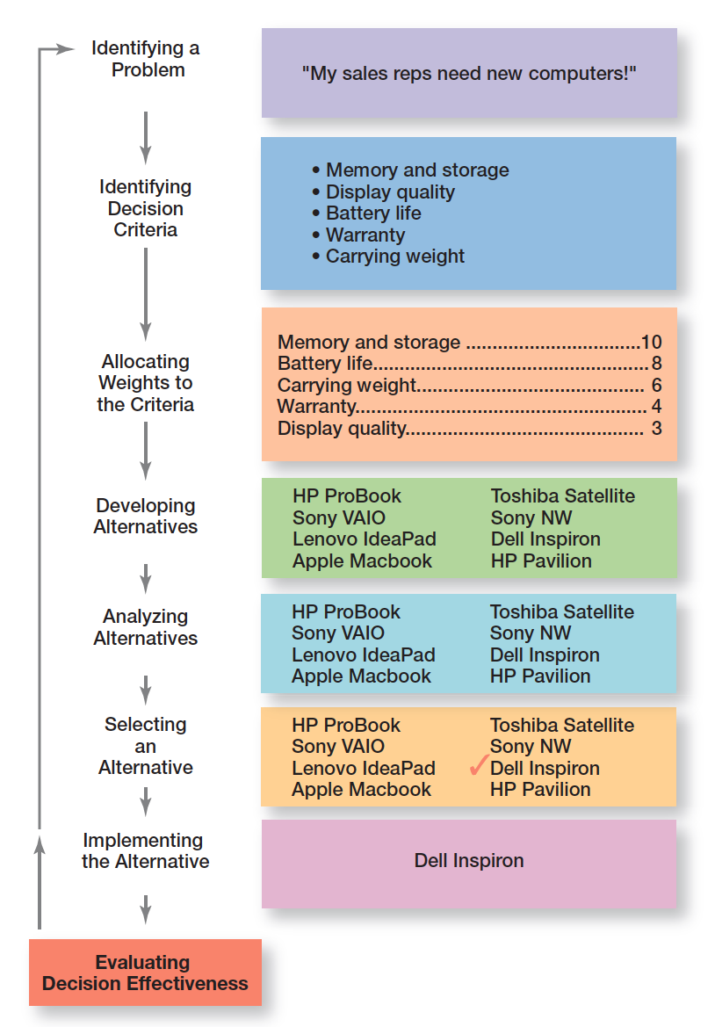
Course figure: eight-step decision-making process (Making Decisions, slide 4).

1. What is a Decision?
A decision is a choice among two or more alternatives. The course stresses that decision making is a process, not merely a single act of choosing.

2. The 8-Step Decision-Making Process — MUST MEMORIZE
Stage | Exam explanation
1. Identify a problem | Find the gap between the existing condition and the desired condition.
2. Identify decision criteria | Determine the factors that matter in solving the problem.
3. Allocate weights | Give greater priority to criteria that matter more.
4. Develop alternatives | List viable solutions; do not evaluate them yet.
5. Analyze alternatives | Evaluate alternatives against the criteria/weights.
6. Select an alternative | Choose the alternative with the strongest overall result under the chosen approach.
7. Implement the alternative | Put the choice into action, communicate it and obtain commitment.
8. Evaluate decision effectiveness | Check whether the problem was actually resolved; if not, revisit earlier steps.

One-line memory
Problem → Criteria → Weights → Alternatives → Analyze → Select → Implement → Evaluate.

3. Laptop Example — What the Exam Expects
The course example uses a sales manager whose representatives need new laptops. Criteria include memory/storage, battery life, carrying weight, warranty and display quality. The criteria are weighted before alternatives are scored. The important exam point is not arithmetic; it is being able to explain each stage in order.
Criterion | Illustrative weight in course example
Memory and storage | 10
Battery life | 8
Carrying weight | 6
Warranty | 4
Display quality | 3

The course example’s final selection is Dell Inspiron after weighted evaluation. Because your syllabus explicitly says no numerical questions, treat the table as an illustration of the process, not as a calculation exercise.

4. Rational Decision-Making
Rational decision making means choices are logical and consistent and aim to maximize value.

Assumptions of rationality
- The decision maker is logical and objective.
- The problem is clear and unambiguous.
- The goal is clear and specific.
- All relevant alternatives and consequences are known.
- The alternative that best achieves the goal is selected.
- For managers, decisions are made in the best interest of the organization.

5. Bounded Rationality and Satisficing
Bounded rationality means decision makers are rational but limited by their ability to process information. Because complete analysis is impossible, they often satisfice: they choose an option that is “good enough” rather than mathematically optimal.
Concept | Meaning | Example
Rationality | Attempts an objectively best/maximum-value choice. | Compare all relevant alternatives when information is complete.
Bounded rationality | Rationality within limits of time, information and processing ability. | Shortlist a few plausible vendors instead of every vendor in the market.
Satisficing | Accept a satisfactory solution rather than maximizing. | Choose the first supplier meeting all minimum standards.

6. Escalation of Commitment
Escalation of commitment is increasing commitment to a previous decision despite evidence that it may have been wrong.
Example: A company continues funding a failing product because “we have already spent so much on it.”
Key distinction
Escalation of commitment often appears together with the sunk-cost error, but they are not identical: escalation is the continued commitment; sunk-cost error is the cognitive tendency to let past, unrecoverable costs influence current choices.

7. Intuitive Decision-Making
Intuition means making decisions using experience, feelings and accumulated judgment.
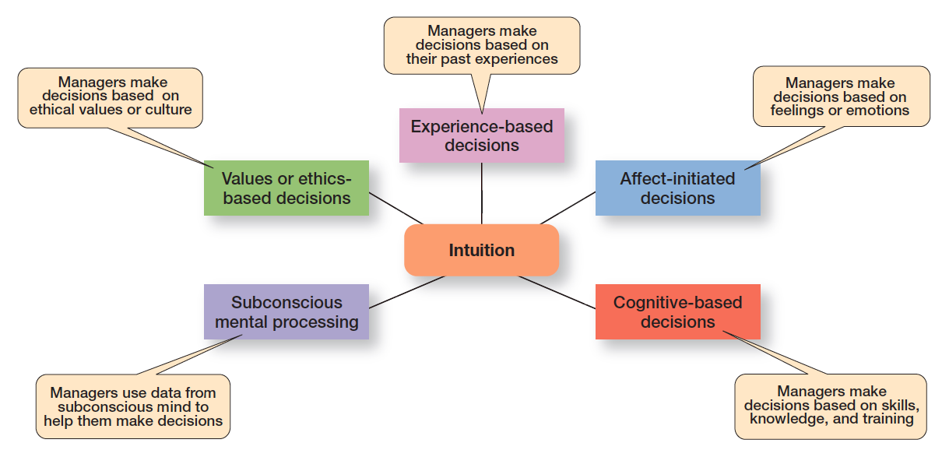
Course figure: five aspects of intuition (Making Decisions, slide 20).
Type of intuition | Course meaning
Experience-based | Decisions draw on patterns learned from past experience.
Affect-initiated | Feelings or emotions trigger the judgment.
Cognitive-based | Skills, knowledge and training support the judgment.
Subconscious mental processing | The subconscious mind contributes information/pattern recognition.
Values or ethics-based | Decisions draw on ethical values or culture.

8. When to Use Rationality, Bounded Rationality and Intuition
Approach | More useful when… | Risk
Rationality | Problem is structured; information is available; time exists for analysis. | Can become slow and unrealistic if information is never complete.
Bounded rationality | Time/information/processing capacity is limited but a workable solution is needed. | Can settle for a merely adequate option.
Intuition | Manager has substantial experience; situation is ambiguous or time-sensitive; patterns are difficult to quantify. | Can be distorted by bias, emotion or false confidence.

9. Evidence-Based Management (EBMgt)
EBMgt is the systematic use of the best available evidence to improve management practice.
- Manager’s expertise and judgment.
- External evidence evaluated by the manager.
- Opinions, preferences and values of stakeholders.
- Relevant internal organizational factors, context and circumstances.

10. Types of Problems and Decisions
Structured problems | Unstructured problems
Straightforward, familiar and clearly defined. | New or unusual; information is ambiguous or incomplete.
Often use programmed decisions. | Often require nonprogrammed decisions.
Routine solutions are available. | Custom-made judgment/creativity often required.

11. Programmed Decisions
A programmed decision is repetitive and can be handled through a routine approach.
Tool | Meaning | Example
Procedure | Series of sequential steps for a well-structured problem. | Procurement workflow for standard equipment.
Rule | Explicit statement of what can or cannot be done. | Late-arrival policy or spending ceiling.
Policy | General guideline or parameter for decisions; allows interpretation. | Refund policy stating broad customer-service boundaries.

12. Nonprogrammed Decisions
A nonprogrammed decision is unique, nonrecurring and requires a custom-made solution. These decisions become more common at higher managerial levels.
Characteristic | Programmed | Nonprogrammed
Problem | Structured | Unstructured
Level | Lower levels | Upper levels
Frequency | Repetitive | New/unusual
Information | Readily available | Ambiguous/incomplete
Goals | Clear/specific | Vague or less defined
Time | Shorter | Longer
Solution relies on | Rules/procedures/policies | Judgment/creativity

13. Decision-Making Conditions
Condition | Definition | What manager knows
Certainty | Outcomes of alternatives are known. | Outcome is known.
Risk | Likelihood/probability of outcomes can be estimated. | Probabilities can be assigned.
Uncertainty | Neither certainty nor reasonable probability estimates are available. | Outcomes/probabilities are unclear.

Expected value — concept only
Under risk, managers can combine expected revenue/payoff with estimated probabilities to obtain an expected value. The source deck includes an example, but your syllabus says no numerical questions, so learn the concept rather than practicing calculations.

14. Payoff Matrix and Regret — Concept Only
A payoff matrix shows how each strategy performs under different competitor/environment states. Under uncertainty, a manager can also construct a regret matrix. The course exhibit defines regret by comparing each payoff with the best payoff available for the same event and then choosing a strategy with the lowest maximum regret (minimax regret). No numerical questions are expected.

15. Heuristics
Heuristics are mental shortcuts or rules of thumb that simplify decisions when information is overwhelming, incomplete or ambiguous. They save time and mental effort, but can produce systematic cognitive biases.

16. The 12 Decision-Making Biases — MUST MEMORIZE
Bias | Exam-ready meaning
Overconfidence bias | Thinking you know more than you actually do or overestimating your performance.
Immediate gratification bias | Preferring immediate rewards and avoiding immediate costs.
Anchoring effect | Fixating on initial information and failing to adjust enough when new evidence appears.
Selective perception bias | Selecting and interpreting information through existing perceptions.
Confirmation bias | Seeking information that supports prior beliefs and discounting contradictory information.
Framing bias | Focusing attention on selected aspects of a situation while ignoring others.
Availability bias | Judging from information that is vivid or easy to recall, especially recent events.
Representation bias | Assuming similarity means two situations are meaningfully identical.
Randomness bias | Creating meaning or patterns out of random events.
Sunk-cost error | Letting past, unrecoverable expenditures influence current decisions.
Self-serving bias | Taking quick credit for success and blaming outside factors for failure.
Hindsight bias | Believing after an event that you predicted it, even if you did not.

17. Effective Decision-Making Process
1. Focus on what is important.
2. Be logical and consistent.
3. Blend objective/analytical thinking with subjective/intuitive thinking where useful.
4. Use only as much information and analysis as the problem requires.
5. Gather relevant information and informed opinions.
6. Keep the process straightforward, reliable, flexible and usable.

18. Design Thinking — 1 Mark
Design thinking shifts away from purely linear, math-heavy analysis toward a creative and human-centered approach to complex problems. The course stresses collaborative problem identification and attention to emotional as well as rational elements.
1-mark answer
Design thinking is a creative, human-centered approach to solving complex management problems, emphasizing deep understanding of the situation, alternative generation and iteration.

19. Big Data and Decision Making — 1 Mark
Big data is a vast amount of quantifiable information that can be analyzed using sophisticated processing. The course notes the “3Vs”: high volume, high velocity and/or high variety. Big data can strengthen decisions, but collecting/analyzing data without a clear goal is wasted effort. Good judgment is still necessary.
1-mark answer
Big data can improve decision making through large-scale analysis and predictive tools, but data must be tied to a clear decision problem and tempered with managerial judgment.

20. Decision-Making Guidelines
- Understand cultural differences.
- Create standards for what a good decision looks like.
- Know when it is time to stop or reverse an ineffective decision.
- Use an effective decision-making process.
- Develop the ability to think clearly.

UNIT 4 — Question Bank
[SHORT] What is a decision?
Answer / points: A choice among two or more alternatives.
[SHORT] What is a problem?
Answer / points: A discrepancy between an existing condition and a desired condition.
[SHORT] What is a decision criterion?
Answer / points: A factor that is important in solving the problem.
[SHORT] What is satisficing?
Answer / points: Accepting a solution that is good enough rather than maximizing.
[SHORT] What is escalation of commitment?
Answer / points: Continuing/increasing commitment to a previous decision despite evidence it may be wrong.
[SHORT] Define intuition.
Answer / points: Decision making based on experience, feelings and accumulated judgment.
[SHORT] Name the five types of intuition.
Answer / points: Experience-based, affect-initiated, cognitive-based, subconscious mental processing, values/ethics-based.
[SHORT] Define programmed decision.
Answer / points: A repetitive decision handled using a routine approach.
[SHORT] Define nonprogrammed decision.
Answer / points: A unique, nonrecurring decision requiring a custom-made solution.
[SHORT] Differentiate certainty, risk and uncertainty.
Answer / points: Certainty: outcomes known; risk: probabilities estimable; uncertainty: neither outcomes nor reasonable probabilities are known.
[SHORT] Define heuristic.
Answer / points: A mental shortcut/rule of thumb used to simplify decision making.
[SHORT] What is confirmation bias?
Answer / points: Seeking evidence that supports prior beliefs while discounting contradictory evidence.
[SHORT] What is sunk-cost error?
Answer / points: Letting past unrecoverable costs influence current choices.
[SHORT] What is design thinking?
Answer / points: A creative, human-centered approach to complex problems.
[SHORT] What is big data?
Answer / points: Large quantities of quantifiable information that can be analyzed with sophisticated processing.
[LONG] Explain the eight-step decision-making process with the laptop example.
Answer / points: Problem → criteria → weights → alternatives → analysis → selection → implementation → evaluation. Explain the purpose of each stage and use the laptop example to show how each stage works.
[LONG] Differentiate rationality, bounded rationality and intuition.
Answer / points: Compare assumptions, information available, time and typical use conditions; include examples.
[LONG] Explain programmed and nonprogrammed decisions using Exhibit 2-7.
Answer / points: Compare problem type, managerial level, frequency, information, goals, time and solution method.
[LONG] Explain the 12 decision-making biases with examples.
Answer / points: Define each and give one simple workplace example; do not omit any of the 12.
[LONG] Explain decision-making conditions: certainty, risk and uncertainty.
Answer / points: Define all three; explain how information differs and how managers behave differently under each.
[CASE] Case: A manager keeps funding a failing product because “we have already invested too much.” Identify the bias and explain the correct response.
Answer / points: Sunk-cost error plus possible escalation of commitment. The manager should focus on future consequences and current evidence, not recover the past expenditure.
[CASE] Case: A manager relies on a dramatic recent news story to estimate a rare business risk. Which bias is likely present?
Answer / points: Availability bias. The vivid/recent event is given more weight than objective evidence.
[CASE] Case: Two alternatives are described as “90% survival” vs “10% failure,” and the wording changes the manager’s choice. Which bias?
Answer / points: Framing bias. The way information is presented changes the decision reference point.

UNIT 5 — MANAGING THE EXTERNAL ENVIRONMENT & ORGANIZATIONAL CULTURE
Course-source note: Main source: Managing External Environment & Organizational Culture. The deck covers the manager’s omnipotent/symbolic views, constraints, six external-environment components, environmental uncertainty matrix, stakeholders and organizational culture including seven dimensions, strong vs weak culture, Exhibit 3-8, how culture is learned, culture’s impact on managers, innovative culture and customer-responsive culture.
UNIT 5 EXAM MAP
Omnipotent vs symbolic → constraints → external environment / PESTEL-style components + global → uncertainty matrix ⭐ → stakeholders → organizational culture → 3-part definition → 7 dimensions → strong vs weak → Exhibit 3-8 → how employees learn culture → how culture affects P-O-L-C → innovative culture → customer-responsive culture.

1. Manager: Omnipotent or Symbolic?
View | Core idea | Examples from the course
Omnipotent view | Managers are directly responsible for organizational success or failure. | Corporate turnaround, direct blame for scandals.
Symbolic view | A large part of success/failure is shaped by external forces outside managers’ control. | Recession, industry-wide disruption, natural disasters, pandemics.

Best exam conclusion
Managers are neither all-powerful nor helpless. Managerial discretion is constrained by the external environment and by internal organizational culture.

2. Managerial Constraints
The course distinguishes two broad sources of constraints: external constraints come from the organization’s environment; internal constraints come from organizational culture.
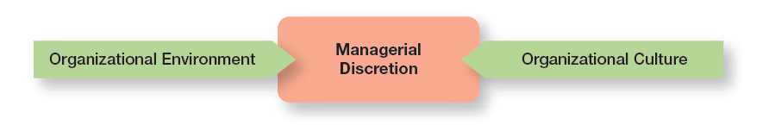
Course exhibit: constraints on managerial discretion (External Environment & Organizational Culture, slide 4).

3. External Environment
The external environment consists of factors and forces outside the organization that affect its performance.
Component | What it covers | Examples
Political / Legal | Government, law, regulation, political stability. | Employment law, tax, regulation, government stability
Economic | Interest rates, inflation, disposable income, stock-market changes, business cycles. | Recession, inflation, interest rate movement
Demographic | Population characteristics such as age, gender, education, location, income and family composition. | Ageing population, youth population
Sociocultural | Values, attitudes, lifestyles, beliefs, traditions, tastes and behavior patterns. | Lifestyle trends, changing customer values
Technological | Scientific/industrial innovation. | AI, automation, digital platforms
Global | Globalization and world-economy issues. | Cross-border manufacturing, global commodity markets

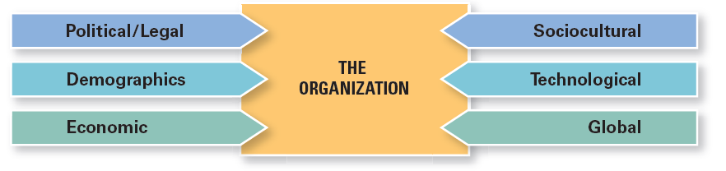
Course exhibit: components of the external environment (External Environment & Organizational Culture, slide 6).

4. PESTEL Connection
For exam purposes, map the course’s six components to the common PESTEL framework as follows: Political/Legal = P + L; Economic = E; Demographic and Sociocultural = S; Technological = T; Global is treated separately in the course deck as a global component. If your teacher asks for “PESTEL,” write the conventional P-E-S-T-E-L structure and explain each briefly, but keep the course terminology visible.
PESTEL | Course deck connection
P — Political | Political conditions/stability
E — Economic | Interest rates, inflation, disposable income, business cycle
S — Social | Demographic + sociocultural trends
T — Technological | Scientific/industrial innovations
E — Environmental | Environmental conditions/sustainability — standard PESTEL extension; not separately detailed in this deck
L — Legal | Government and legal rules

5. Economic Environment
- Interest rates affect borrowing and investment.
- Inflation changes costs and purchasing power.
- Disposable income affects customer demand.
- Stock-market fluctuations affect business confidence and finance.
- Business cycles move through growth/peak/drop/recovery patterns.
- Commodity/raw-material prices can change operating costs.

6. Global Economic Context — Know the concept, not the separate Global Business chapter
The external-environment deck treats globalization as one environment component: cross-border manufacturing, international supply chains and global commodity markets can affect organizations. Your syllabus separately says the “Global Environment” chapter will not come, so do not spend time on regional trade alliances, WTO, MNC structures or internationalization methods from the separate global-environment deck.

7. Demographic Environment
Demographic factors concern population characteristics that affect markets, labor supply and workplace behavior. The course uses generational differences to illustrate how employees may differ in preferred communication and technology use.
Group used in the course example | Illustrative workplace tendency
Gen X / Baby Boomers | More preference for face-to-face meetings, structure and comprehensive reports in the course illustration.
Gen Y / Millennials | More comfort with collaborative digital tools, process streamlining and work-life balance in the illustration.
Post-Millennials / Gen Z | More preference for instant/visual communication, cloud files and intuitive software interfaces in the illustration.

Exam caution: these are course examples, not rules for every individual. Use them only to explain why demographics can matter to managerial practice.

8. How the External Environment Affects Managers
The course highlights jobs and employment as one of the strongest constraints. Economic shifts, recessions and labor-market changes can change staffing decisions, create layoffs or encourage use of freelancers and temporary workers.

9. Environmental Uncertainty — HIGH PRIORITY
Environmental uncertainty is the degree of change and complexity in an organization’s environment.
Dimension | Low end | High end
Change | Stable: little/minimal unpredictable change. | Dynamic: frequent and unpredictable change.
Complexity | Simple: few components and less knowledge needed. | Complex: many different components and much more knowledge needed.

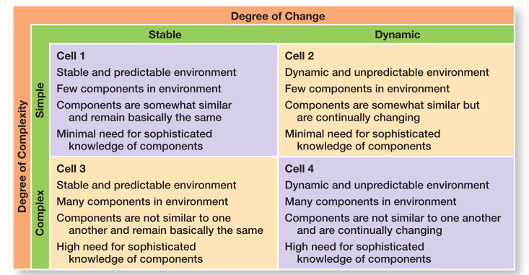
Course Exhibit 3-3: Environmental Uncertainty Matrix. Cell 1 = lowest uncertainty; Cell 4 = highest uncertainty.
Cell | Environment | Example from course
1 | Stable + simple | Local dry cleaner
2 | Dynamic + simple | Fast-fashion boutique
3 | Stable + complex | Appliance manufacturer
4 | Dynamic + complex | Smartphone/tech giant

Exam phrase
Cell 1 has the lowest uncertainty and gives managers the greatest influence on outcomes; Cell 4 has the highest uncertainty and gives managers the least influence because the environment is both complex and rapidly changing.

10. Stakeholders
Stakeholders are constituencies in the organization’s environment that are affected by the organization’s decisions and actions. Stakeholders can also influence the organization.
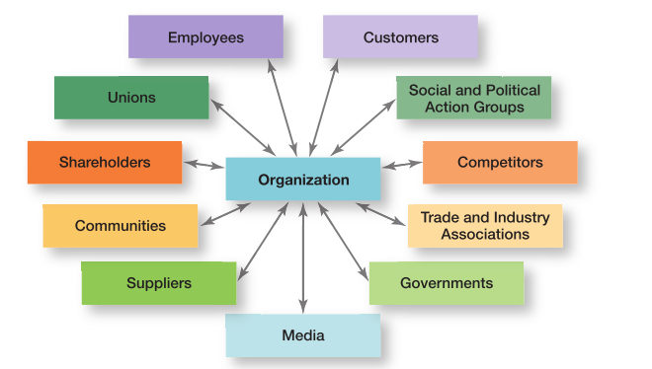
Course Exhibit 3-4: organizational stakeholders.
Stakeholder | Typical concern / influence
Employees | Jobs, pay, working conditions, development
Customers | Quality, price, service, safety
Shareholders | Returns, risk, governance
Suppliers | Contracts, payment, demand stability
Communities | Jobs, environment, local impact
Governments | Compliance, taxes, public policy
Competitors | Market behavior, pricing, innovation
Media | Public information and reputation
Trade/industry associations | Industry standards and interests
Social/political action groups | Social, political or environmental concerns
Unions | Employee representation and labor relations

11. Benefits of Good Stakeholder Relationships
- Improved predictability of environmental changes.
- Better awareness of upcoming regulations.
- Greater chance of successful innovation.
- Increased trust among stakeholders.
- Greater organizational flexibility during difficult periods or sudden crises.

12. Organizational Culture — 3-Part Definition
Organizational culture is the organization’s “personality”: the shared set of values, beliefs, attitudes and core behaviors that shape how people interact and work.
Three characteristics of culture | Meaning
Perception | Culture is not physically visible; employees perceive it from what they experience.
Descriptive | Culture describes how members perceive and describe “how things are”; it is not simply whether they like it.
Shared | Members at different levels tend to describe core aspects of the culture in similar terms.

13. Seven Dimensions of Organizational Culture — MUST MEMORIZE
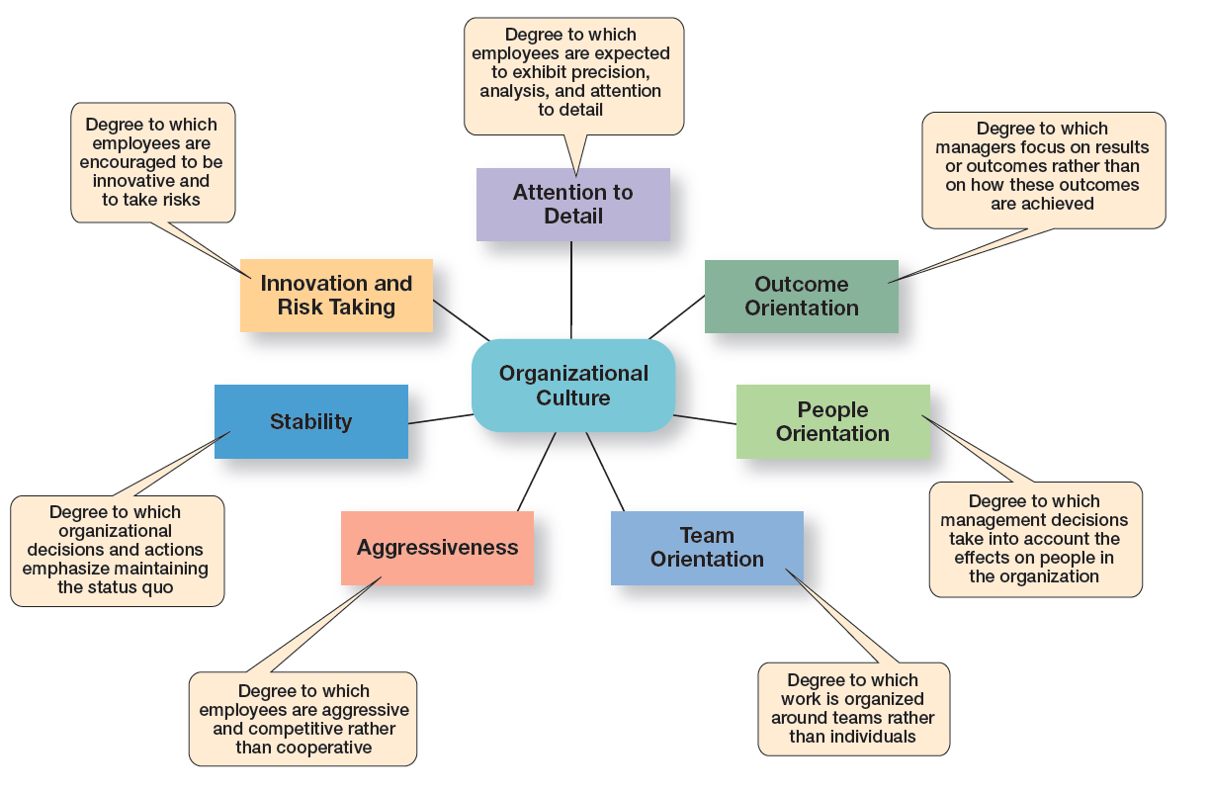
Course Exhibit 3-5: seven dimensions of organizational culture.
Dimension | Meaning
Innovation and Risk Taking | Degree to which employees are encouraged to innovate and take risks.
Attention to Detail | Degree to which employees are expected to show precision, analysis and attention to detail.
Outcome Orientation | Degree to which managers focus on results/outcomes rather than how those outcomes are achieved.
People Orientation | Degree to which management decisions consider effects on people.
Team Orientation | Degree to which work is organized around teams rather than individuals.
Aggressiveness | Degree to which employees are aggressive and competitive rather than cooperative.
Stability | Degree to which decisions/actions emphasize maintaining the status quo.

14. Contrasting Cultures
Lower / rigid culture signals | Higher / adaptive culture signals
Risk-taking and change discouraged | Risk-taking and change rewarded
Creativity discouraged | Creativity and innovation rewarded
Close supervision | Management trusts employees
Work designed around individuals | Work designed around teams

The lecture’s examples show that different organizations can emphasize different dimensions. Use examples carefully: the important idea is that one or more dominant dimensions shape the organization’s “personality.”

15. Strong vs Weak Culture
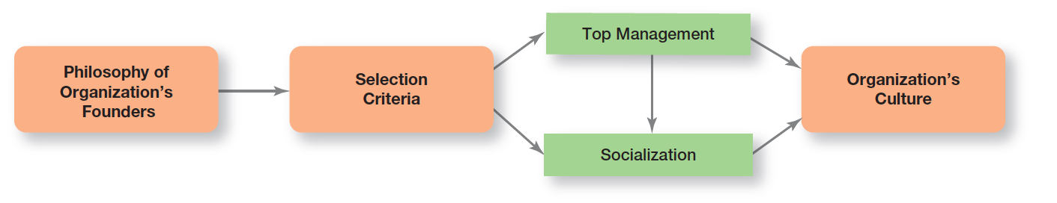
Course Exhibit 3-8 is covered in the next section; it shows how culture is established and maintained.
Strong culture | Weak culture
Values widely shared | Values limited to a few people, often top management
Consistent messages about what is important | Contradictory messages about what matters
Employees strongly identify with culture | Employees have little identification
Strong connection between values and behavior | Little connection between values and behavior
More employee loyalty | Less employee loyalty
Associated in the course material with higher organizational performance | Associated in the course material with lower performance

Important limitation
A very strong culture can also make change harder when the external environment shifts quickly. Strong does not automatically mean adaptable.

16. Where Culture Comes From and How It Continues — Exhibit 3-8
Course Exhibit 3-8: establishing and maintaining organizational culture.
1. Founders’ philosophy, vision, values and beliefs establish the initial direction.
2. Selection criteria screen for people who fit the culture.
3. Top management actions, words and decisions establish behavioral norms.
4. Socialization/training teaches employees how to adapt to the culture.
5. The result is an ongoing organizational culture that reinforces these expectations.

17. How Employees Learn Culture
Mechanism | Meaning
Stories | Narratives about founders, successes, rule breaking, mistakes and important events.
Rituals | Repeated activities that express and reinforce important values and goals.
Material artifacts | Office layout, dress, executive perks, reserved parking, facilities and visible symbols.
Language | Unique terminology, acronyms and jargon that identify members and processes.

18. How Culture Affects Managers
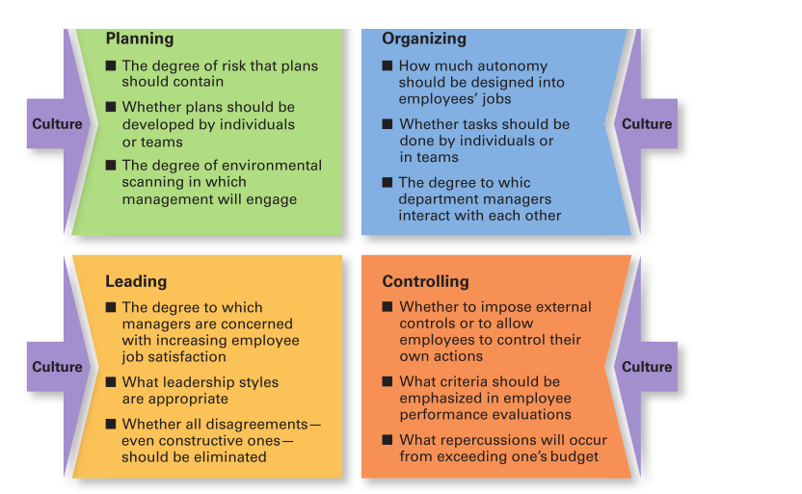
Course Exhibit 3-9: culture affects planning, organizing, leading and controlling.
Managerial function | How culture can influence decisions
Planning | Risk level accepted; individual vs team planning; degree of environmental scanning.
Organizing | Autonomy in jobs; individual vs team work; how departments interact.
Leading | Importance of employee satisfaction; acceptable leadership style; whether disagreement is encouraged.
Controlling | Whether controls are external or employee-driven; performance criteria; consequences for exceeding budgets.

Course illustration: a “ready-aim-fire” culture studies and analyzes before acting, while a “ready-fire-aim” culture acts first and analyzes afterward.

19. Creating an Innovative Culture
- Involve employees in long-term goals and help them see their work as meaningful.
- Give employees autonomy for initiatives.
- Build trust and openness so new ideas can be shared.
- Use a playful/humorous atmosphere where appropriate to reduce stress and spark ideas.
- Encourage debate and questioning of the status quo.
- Treat risk and failure as learning opportunities rather than only as punishable events.

20. Customer-Responsive Culture
Characteristic | Managerial implication
Type of employee | Hire people who are friendly, attentive, enthusiastic, patient and good listeners.
Type of job environment | Give employees enough control to satisfy customers without rigid unnecessary rules.
Empowerment | Allow service-contact employees discretion for day-to-day job decisions.
Role clarity | Train employees continuously so they know product/service and behavioral expectations.
Consistent desire to satisfy and delight | Make the organizational commitment to customer satisfaction clear, even when employees must act beyond narrow job descriptions.

UNIT 5 — Question Bank
[SHORT] What is the omnipotent view?
Answer / points: Managers are directly responsible for organizational success or failure.
[SHORT] What is the symbolic view?
Answer / points: External forces explain much of organizational success/failure.
[SHORT] What constrains managerial discretion?
Answer / points: External environment and internal organizational culture.
[SHORT] Define external environment.
Answer / points: Factors and forces outside the organization that affect performance.
[SHORT] Name the six external-environment components in the course.
Answer / points: Political/legal, economic, demographic, sociocultural, technological and global.
[SHORT] Define environmental uncertainty.
Answer / points: Degree of change and complexity in an organization’s environment.
[SHORT] What are the two dimensions of uncertainty?
Answer / points: Degree of change and degree of complexity.
[SHORT] Which cell has the highest uncertainty?
Answer / points: Cell 4: dynamic and complex.
[SHORT] Define stakeholder.
Answer / points: A constituency affected by organizational decisions/actions that can also influence the organization.
[SHORT] Define organizational culture.
Answer / points: Shared values, beliefs, attitudes and core behaviors that shape how people interact and work.
[SHORT] What are the three properties of organizational culture in the course?
Answer / points: Perception, descriptive, shared.
[SHORT] Name the seven dimensions of culture.
Answer / points: Innovation/risk, attention to detail, outcome orientation, people orientation, team orientation, aggressiveness, stability.
[SHORT] What is a strong culture?
Answer / points: A culture in which key values are widely accepted and strongly held by employees.
[SHORT] Name four ways employees learn culture.
Answer / points: Stories, rituals, material artifacts, language.
[LONG] Explain the environmental uncertainty matrix (Exhibit 3-3).
Answer / points: Use two axes: change (stable→dynamic) and complexity (simple→complex). Explain all four cells and why Cell 4 is most uncertain.
[LONG] Explain organizational culture and its seven dimensions.
Answer / points: Start with 3 characteristics of culture, then define all seven dimensions with a short example if possible.
[LONG] Explain strong vs weak organizational culture.
Answer / points: Use the comparison table; add the limitation that very strong cultures can resist rapid change.
[LONG] Explain how organizational culture is established and maintained (Exhibit 3-8).
Answer / points: Founders’ philosophy → selection criteria → top management norms → socialization/training → culture.
[LONG] Explain stakeholder relationships and their benefits.
Answer / points: Define stakeholders, list major groups, explain two-way influence and benefits such as predictability, innovation, trust and flexibility.
[CASE] Case: A company encourages experimentation, gives teams autonomy and treats failures as learning. Identify the relevant culture dimensions.
Answer / points: Innovation/risk taking, team orientation, people orientation and likely a lower emphasis on rigid stability/control.
[CASE] Case: A firm has stable demand, few competitors and few environmental components. Which uncertainty cell is it in?
Answer / points: Cell 1: stable and simple, the lowest uncertainty.

FINAL — HIGH-YIELD REVISION SHEETS
The night-before list
Do not try to reread everything. Memorize the lists and distinctions below, then answer the question bank from memory.

A. 25 Things You Must Be Able to Write Without Looking
1. P-O-L-C: Planning, Organizing, Leading, Controlling.
2. Three levels: Top, Middle, First-line.
3. Mintzberg: Interpersonal, Informational, Decisional.
4. Mintzberg 10 roles.
5. Katz: Technical, Human, Conceptual.
6. Fayol’s 14 principles.
7. Taylor’s 4 principles.
8. Taylor’s time and motion studies, differential piece-rate, standardization.
9. Weber’s bureaucracy: hierarchy, division of labor, rules, impersonality, merit.
10. Human relations: Mayo/Hawthorne, Maslow, McGregor, Follett.
11. Systems: organization as an interconnected whole.
12. Contingency: no single best way.
13. PDCA: Plan, Do, Check, Act.
14. Strategic vs tactical plans.
15. SWOT and internal vs external distinction.
16. MBO.
17. 8-step decision process.
18. Rationality vs bounded rationality vs intuition.
19. Five types of intuition.
20. Programmed vs nonprogrammed decisions.
21. Certainty vs risk vs uncertainty.
22. Heuristics + 12 biases.
23. Omnipotent vs symbolic view.
24. Environmental uncertainty matrix.
25. Seven dimensions of organizational culture + strong vs weak + Exhibit 3-8.

B. One-Line Memory Chains
Topic | Memory chain
Management functions | P-O-L-C
Managerial roles | Interpersonal → Informational → Decisional
Katz skills | Technical → Human → Conceptual
Classical thinkers | Taylor → Fayol → Weber
Evolution | Classical → Human Relations → Quantitative → Systems → Contingency → Modern
Planning | Mission/goal → external analysis → internal analysis → strategy → implementation → evaluation
SWOT | S/W internal; O/T external
Decision process | Problem → Criteria → Weights → Alternatives → Analyze → Select → Implement → Evaluate
Decision conditions | Certainty → Risk → Uncertainty
Bias cluster 1 | Overconfidence → Immediate gratification → Anchoring
Bias cluster 2 | Selective perception → Confirmation → Framing
Bias cluster 3 | Availability → Representation → Randomness
Bias cluster 4 | Sunk cost → Self-serving → Hindsight
External environment | Political/Legal → Economic → Demographic → Sociocultural → Technological → Global
Uncertainty | Stable/Simple = low → Dynamic/Complex = high
Culture dimensions | Innovation → Detail → Outcome → People → Team → Aggressiveness → Stability
Culture maintenance | Founders → Selection → Top management → Socialization → Culture
Culture learning | Stories → Rituals → Artifacts → Language

C. High-Value Comparisons
Pair | Core distinction
Manager vs operative | Manager directs others; operative directly performs work.
Taylor vs Fayol | Taylor = shop-floor efficiency; Fayol = whole-organization administration.
Fayol vs Weber | Fayol = principles of management; Weber = formal bureaucracy.
Rationality vs bounded rationality | Optimal/ideal analysis vs limited information and processing.
Bounded rationality vs intuition | Good-enough analytical decision vs experience/feeling/judgment.
Programmed vs nonprogrammed | Routine/structured vs unique/unstructured.
Certainty vs risk vs uncertainty | Outcome known vs probabilities estimable vs probabilities not reasonably estimable.
Omnipotent vs symbolic | Managers as primary cause vs environment as major constraint.
Strong vs weak culture | Values widely shared/strongly held vs limited/weakly shared.
Functional vs divisional vs matrix | Function-based vs product/geography/customer-based vs dual authority.

D. 8–10 Mark Answer Templates
Question type | Suggested structure
Theory / approach | Definition → central idea → components → example → advantages → criticisms → conclusion
Process | Definition → numbered stages → explain each → mini example → conclusion
Comparison | Definition of both → comparison table → example → when each fits → conclusion
Framework (SWOT/PESTEL/uncertainty) | Define → diagram/table → explain each element → example → managerial implication
Case study | Identify problem → identify concept → evidence from case → apply steps → recommendation → expected result

FINAL — MASTER QUESTION BANK
Use this section as a mock paper generator. First cover the answers, attempt the question, and then compare your response with the expected points.

Section A — Short Questions (1–2 marks)
1. Define management.
2. Define organization.
3. State the four functions of management.
4. Define planning.
5. Define controlling.
6. Who is a manager?
7. Name the three management levels.
8. Name Katz’s three skills.
9. Name Mintzberg’s three role categories.
10. What is the figurehead role?
11. What is the liaison role?
12. What is the monitor role?
13. What is a resource allocator?
14. What is SWOT?
15. Which SWOT elements are internal?
16. What is MBO?
17. Define organizational structure.
18. What is centralization?
19. What is span of control?
20. Define scientific management.
21. Who is Taylor?
22. Who is Fayol?
23. Who is Weber?
24. State Unity of Command.
25. What is esprit de corps?
26. What is Theory X?
27. What is Theory Y?
28. What is contingency thinking?
29. What is PDCA?
30. What is a decision?
31. What is bounded rationality?
32. What is satisficing?
33. Define escalation of commitment.
34. Define intuition.
35. Name the five types of intuition.
36. Define programmed decision.
37. Define nonprogrammed decision.
38. Differentiate certainty and risk.
39. Define uncertainty.
40. What is a heuristic?
41. What is anchoring bias?
42. What is confirmation bias?
43. What is framing bias?
44. What is sunk-cost error?
45. What is hindsight bias?
46. What is design thinking?
47. What is big data?
48. Define omnipotent view.
49. Define symbolic view.
50. What are managerial constraints?
51. Define external environment.
52. What are the six course components of external environment?
53. Define environmental uncertainty.
54. Name the two dimensions of uncertainty.
55. Which uncertainty cell is highest?
56. Define stakeholder.
57. Define organizational culture.
58. What are culture’s three properties?
59. Name the seven culture dimensions.
60. Define strong culture.
61. Name four ways employees learn culture.

Answer Key — Section A
[SHORT] 1.
Answer / points: Management = planning, organizing, leading and controlling organizational work/resources to achieve goals.
[SHORT] 2.
Answer / points: Organization = two or more people working together in a structured way to achieve goals.
[SHORT] 3.
Answer / points: Planning, organizing, leading, controlling.
[SHORT] 4.
Answer / points: Process of determining objectives and selecting future courses of action.
[SHORT] 5.
Answer / points: Ensuring actual activities conform to plans and goals.
[SHORT] 6.
Answer / points: Person responsible for directing efforts toward organizational goals.
[SHORT] 7.
Answer / points: Top, middle, first-line.
[SHORT] 8.
Answer / points: Technical, human, conceptual.
[SHORT] 9.
Answer / points: Interpersonal, informational, decisional.
[SHORT] 10.
Answer / points: Ceremonial/symbolic duties.
[SHORT] 11.
Answer / points: Connecting link with others.
[SHORT] 12.
Answer / points: Collecting/interpreting information.
[SHORT] 13.
Answer / points: Allocating human/physical/monetary resources.
[SHORT] 14.
Answer / points: Strengths, Weaknesses, Opportunities, Threats.
[SHORT] 15.
Answer / points: Strengths and weaknesses.
[SHORT] 16.
Answer / points: Management by Objectives.
[SHORT] 17.
Answer / points: Arrangement of jobs/roles/authority/coordination.
[SHORT] 18.
Answer / points: Authority concentrated at higher levels.
[SHORT] 19.
Answer / points: Number of direct subordinates.
[SHORT] 20.
Answer / points: Systematic study of work to improve efficiency.
[SHORT] 21.
Answer / points: Frederick Winslow Taylor.
[SHORT] 22.
Answer / points: Henri Fayol.
[SHORT] 23.
Answer / points: Max Weber.
[SHORT] 24.
Answer / points: Employee reports to one boss.
[SHORT] 25.
Answer / points: Team spirit and unity.
[SHORT] 26.
Answer / points: Employees need control and may avoid responsibility.
[SHORT] 27.
Answer / points: Employees can be self-directed and seek responsibility.
[SHORT] 28.
Answer / points: Best approach depends on situation.
[SHORT] 29.
Answer / points: Plan–Do–Check–Act.
[SHORT] 30.
Answer / points: Choice among two or more alternatives.
[SHORT] 31.
Answer / points: Rationality limited by information-processing ability.
[SHORT] 32.
Answer / points: Accepting a good-enough solution.
[SHORT] 33.
Answer / points: Continuing commitment despite evidence a previous choice may be wrong.
[SHORT] 34.
Answer / points: Experience, feelings, accumulated judgment.
[SHORT] 35.
Answer / points: Experience-based, affect-initiated, cognitive-based, subconscious mental processing, values/ethics-based.
[SHORT] 36.
Answer / points: Routine/repetitive decision handled through procedures/rules/policies.
[SHORT] 37.
Answer / points: Unique/nonrecurring decision requiring custom judgment.
[SHORT] 38.
Answer / points: Certainty = outcomes known; risk = probabilities estimable.
[SHORT] 39.
Answer / points: Neither outcomes nor reasonable probabilities are available.
[SHORT] 40.
Answer / points: Mental shortcut/rule of thumb.
[SHORT] 41.
Answer / points: Fixating on initial information.
[SHORT] 42.
Answer / points: Seeking support for existing beliefs and discounting contradictory evidence.
[SHORT] 43.
Answer / points: Letting presentation/frame shape the choice.
[SHORT] 44.
Answer / points: Letting past unrecoverable costs influence current decisions.
[SHORT] 45.
Answer / points: Believing after an event that you predicted it.
[SHORT] 46.
Answer / points: Creative, human-centered approach to complex problems.
[SHORT] 47.
Answer / points: Large quantifiable data sets analyzed with sophisticated processing.
[SHORT] 48.
Answer / points: Managers directly responsible for success/failure.
[SHORT] 49.
Answer / points: External forces explain much of success/failure.
[SHORT] 50.
Answer / points: External environment + internal culture constrain discretion.
[SHORT] 51.
Answer / points: Factors/forces outside the organization that affect performance.
[SHORT] 52.
Answer / points: Political/legal, economic, demographic, sociocultural, technological, global.
[SHORT] 53.
Answer / points: Degree of change and complexity in the environment.
[SHORT] 54.
Answer / points: Degree of change + degree of complexity.
[SHORT] 55.
Answer / points: Cell 4: dynamic + complex.
[SHORT] 56.
Answer / points: Constituency affected by organizational decisions/actions that can also influence it.
[SHORT] 57.
Answer / points: Shared values, beliefs, attitudes and core behaviors shaping work and interaction.
[SHORT] 58.
Answer / points: Perception, descriptive, shared.
[SHORT] 59.
Answer / points: Innovation/risk; attention to detail; outcome; people; team; aggressiveness; stability.
[SHORT] 60.
Answer / points: Key values widely accepted and strongly held by employees.
[SHORT] 61.
Answer / points: Stories, rituals, material artifacts, language.

Section B — Long Questions (8–10 marks)
[LONG] 1. Explain management and the four functions of management.
[LONG] 2. Discuss the nature/characteristics of management.
[LONG] 3. Explain the three levels of management and their responsibilities.
[LONG] 4. Explain Mintzberg’s managerial roles.
[LONG] 5. Explain Katz’s three managerial skills and their importance at different management levels.
[LONG] 6. Explain planning and its benefits.
[LONG] 7. Differentiate strategic and tactical plans.
[LONG] 8. Explain the strategic management process.
[LONG] 9. Explain SWOT analysis with a suitable example.
[LONG] 10. Explain Management by Objectives (MBO).
[LONG] 11. Explain the elements and types of organization structure.
[LONG] 12. Explain the control process and approaches to control.
[LONG] 13. Explain the evolution of management thought.
[LONG] 14. Explain Scientific Management with Taylor’s four principles, tools, benefits and criticisms.
[LONG] 15. Explain Fayol’s 14 principles of management.
[LONG] 16. Explain bureaucratic management and its advantages/limitations.
[LONG] 17. Explain the Human Relations movement and Hawthorne studies.
[LONG] 18. Explain Maslow’s hierarchy of needs in management.
[LONG] 19. Differentiate Theory X and Theory Y.
[LONG] 20. Explain Systems Theory.
[LONG] 21. Explain the Contingency Approach in detail.
[LONG] 22. Explain TQM and the PDCA cycle.
[LONG] 23. Explain the eight-step decision-making process using the laptop example.
[LONG] 24. Differentiate rationality, bounded rationality and intuition.
[LONG] 25. Explain the five types of managerial intuition.
[LONG] 26. Explain programmed vs nonprogrammed decisions using Exhibit 2-7.
[LONG] 27. Explain certainty, risk and uncertainty as decision conditions.
[LONG] 28. Explain heuristics and the 12 decision-making biases.
[LONG] 29. Explain design thinking and big data in decision making.
[LONG] 30. Explain the omnipotent and symbolic views of management.
[LONG] 31. Explain the external environment and its components.
[LONG] 32. Explain the environmental uncertainty matrix (Exhibit 3-3).
[LONG] 33. Explain stakeholder relationships and their benefits.
[LONG] 34. Explain organizational culture and its three properties.
[LONG] 35. Explain the seven dimensions of organizational culture.
[LONG] 36. Differentiate strong and weak organizational culture.
[LONG] 37. Explain how organizational culture is established and maintained (Exhibit 3-8).
[LONG] 38. Explain how culture affects planning, organizing, leading and controlling.

Section C — Short Case Studies
1. Old laptops, new decision
A manager must replace outdated employee laptops. Apply the eight-step decision process.
Model answer points: Problem → criteria → weights → alternatives → analysis → selection → implementation → evaluation.
2. Failing project
Management continues investing in a failing project because “we have already invested too much.” Identify the bias and explain the correct decision principle.
Model answer points: Sunk-cost error and escalation of commitment. Focus on future consequences and current evidence.
3. Recent disaster dominates risk estimate
A manager overestimates the probability of a rare event because the event was on the news yesterday.
Model answer points: Availability bias.
4. First price anchors negotiation
A supplier quotes a high starting price and all later negotiation stays close to that figure despite market data.
Model answer points: Anchoring effect.
5. Feedback ignored
A manager searches only for reports supporting a strategy and ignores reports showing poor results.
Model answer points: Confirmation bias.
6. Stable local business
A local dry cleaner has few competitors, few customers/suppliers of concern and little unpredictable change. Identify the uncertainty cell.
Model answer points: Cell 1: stable and simple; lowest uncertainty.
7. Tech company environment
A smartphone company faces many competitors, rapidly changing technology, changing customers and multiple regulators. Identify the uncertainty cell and implication for managers.
Model answer points: Cell 4: dynamic and complex; highest uncertainty; managers have less direct control and require sophisticated environmental knowledge.
8. Culture and innovation
Employees are trusted, teams have autonomy, debate is encouraged and failed experiments are treated as learning. Identify culture signals.
Model answer points: Innovation/risk taking, team orientation, empowerment/autonomy and a culture supporting learning.
9. Control failure
A firm has a sales target but never measures actual performance until the end of the year. Identify the missing control stages.
Model answer points: Measurement and comparison are missing; corrective action may also be delayed.
10. Taylor in practice
A factory standardizes every movement, uses time studies and pays more for output above target, but employees complain of boredom. Identify theory and criticism.
Model answer points: Scientific management; criticism = dehumanization, reduced autonomy, repetitive work.

FINAL CRAM SHEET — 5 MINUTES BEFORE THE EXAM
UNIT 1
P-O-L-C | Levels: Top/Middle/First-line | Mintzberg: Interpersonal/Informational/Decisional | Katz: Technical/Human/Conceptual

UNIT 2
Planning → Strategic/Tactical → SWOT → MBO → Organizing/Structure → Directing basics → Controlling: Standard → Measure → Compare → Correct

UNIT 3
Taylor = scientific efficiency | Fayol = 14 principles | Weber = bureaucracy | Mayo = human relations | Maslow = needs | McGregor = X/Y | Systems = whole | Contingency = no single best way | Deming = PDCA | Drucker = MBO

UNIT 4
8 steps: Problem → Criteria → Weights → Alternatives → Analyze → Select → Implement → Evaluate | Rationality vs bounded rationality vs intuition | Programmed vs nonprogrammed | Certainty/Risk/Uncertainty | 12 biases

UNIT 5
Omnipotent vs symbolic | External environment: Political/Legal, Economic, Demographic, Sociocultural, Technological, Global | Uncertainty = change × complexity | Stakeholders | Culture: perception/descriptive/shared | 7 dimensions | Strong vs weak | Founders → Selection → Top management → Socialization

Do not waste revision time on
- Diversity chapter — removed by your corrected syllabus.
- Separate Global Environment chapter — syllabus says it will not come.
- Social Responsibility & Ethics deck — outside your corrected five-unit syllabus.
- Detailed leader theories — your syllabus says no questions about leaders.
- Decision-making overview diagram — syllabus says it will not come.
- Decision-making numericals — syllabus says no numerical questions.
Last instruction
For long questions, write headings. For comparisons, use tables. For case studies, name the concept first and then apply it to the facts. Never answer a case study with only a definition.

